Using the QuickModel
Objective
After completing this lesson, you will be able to use the QuickModel to capture process information in a table-based format.
Using the QuickModel
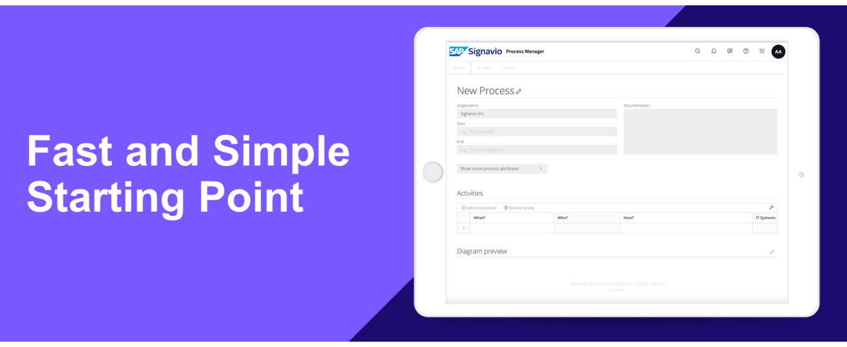
Modeling Made Easy
After getting to know the Editor, you might be wondering if there isn’t a quicker way to capture processes. The answer is the QuickModel, which allows you to create BPMN 2.0 diagrams without having to fully master the notation. With this feature you can simply fill in a table with process information, while the system does the modeling work for you. Some advantages include:
- Easily create correct diagrams. Even if you yourself are unfamiliar with the BPMN 2.0 notation, the end result will be a compliant process model.
- Save time and effort. Let the system do the graphical modeling and arrange the core elements for you, while you provide it with data and determine the process flow.
- Focus on the information. With it being neatly displayed in a table, select which attributes should be shown and supplement your diagrams with additional informative properties.
Starting Point for Business Process Models
The QuickModel is useful for initial, simple modeling. Imagine you want to outline the basic structure of many different processes. You might start with the "happy path" – the sequence a process would follow, where there are no obstructions or errors. But once you want to add elements such as gateways or subprocesses, you’ll face the limitations of QuickModel. To create more complex structures, you need to switch to the Graphical Editor.
Hint
When working in the QuickModel, we recommend adding information about gateways and other details in the documentation. An experienced process modeler can later incorporate them into the diagram.
Watch the video below to see how the QuickModel works in greater detail.
The QuickModel in Practice
Modeling Exercise
Now you have the chance to put what you’ve learned to use! Start the exercise below.

